Lab1: Rolling update

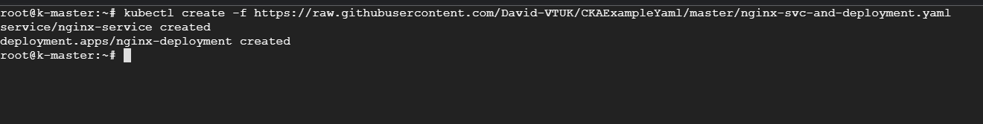

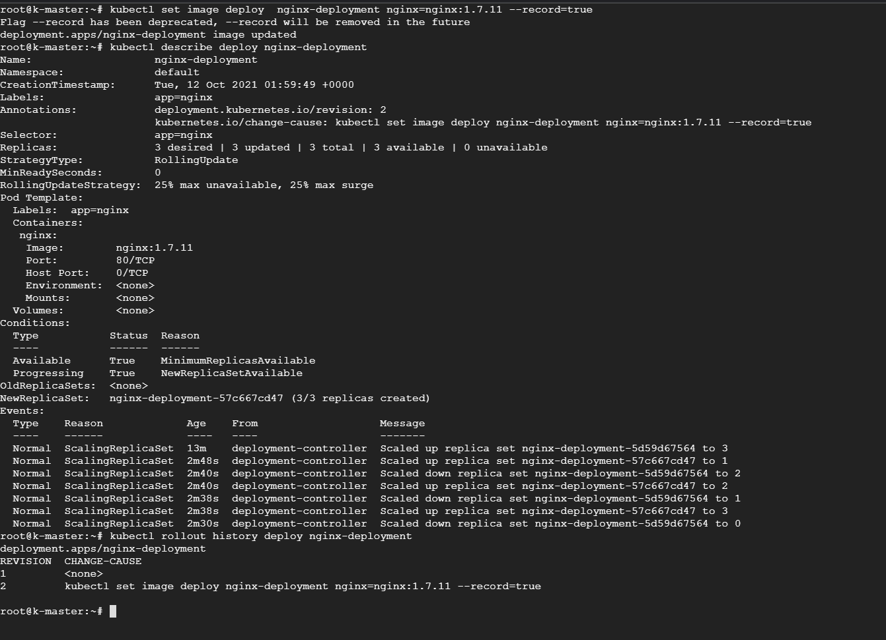

Lab 2:

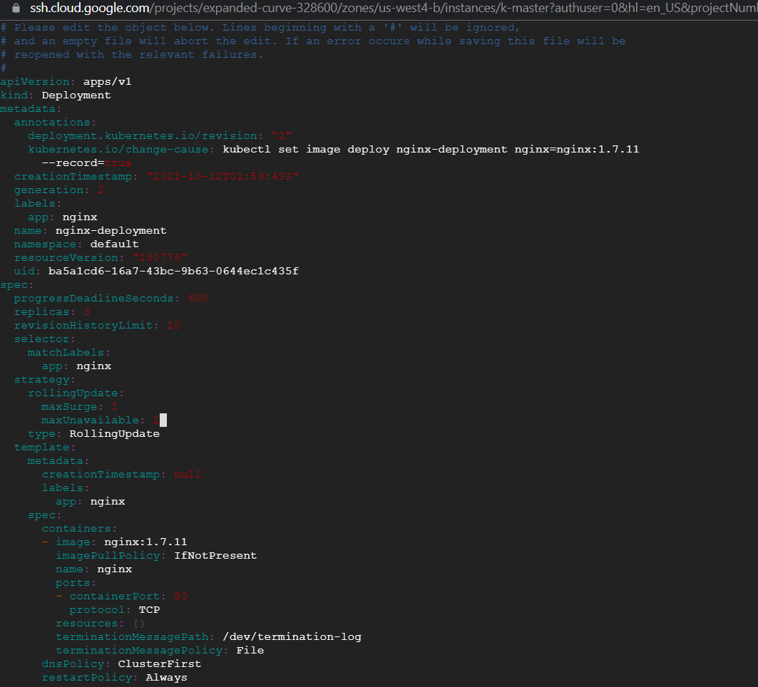

Lab 3:

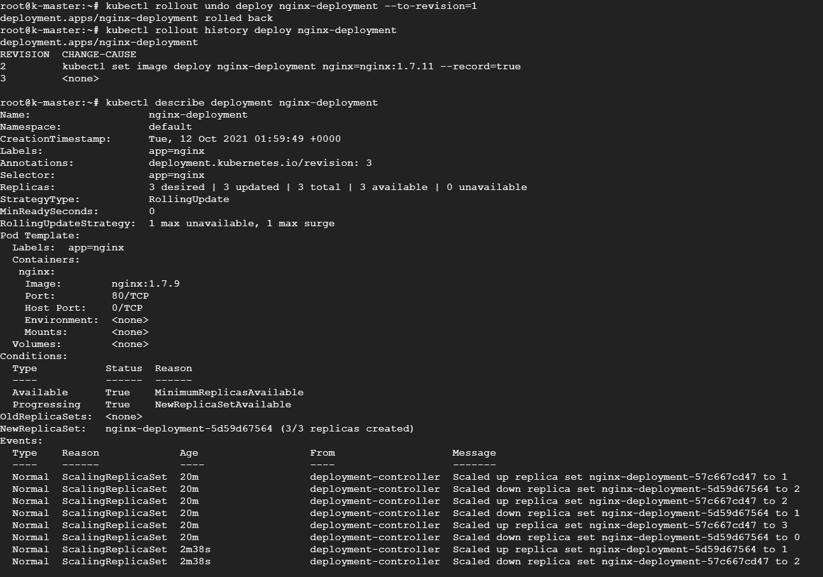

Lab 4:

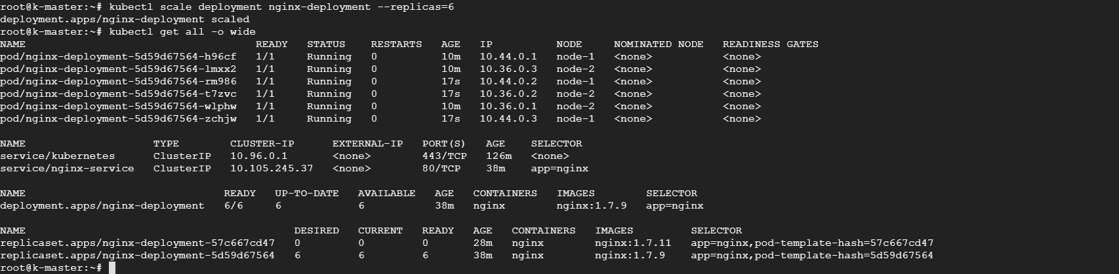

Lab 5:

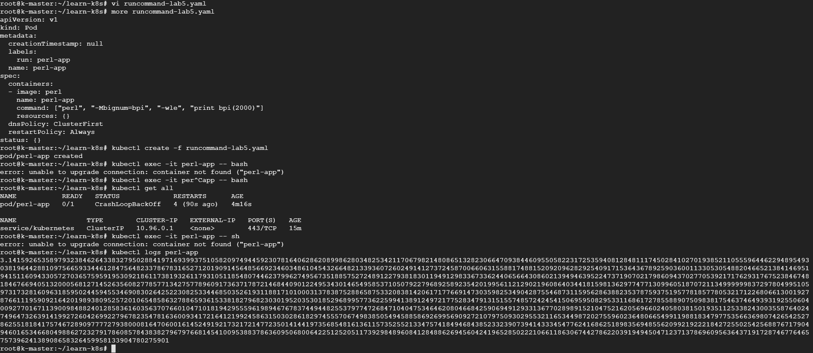

Lab 6:

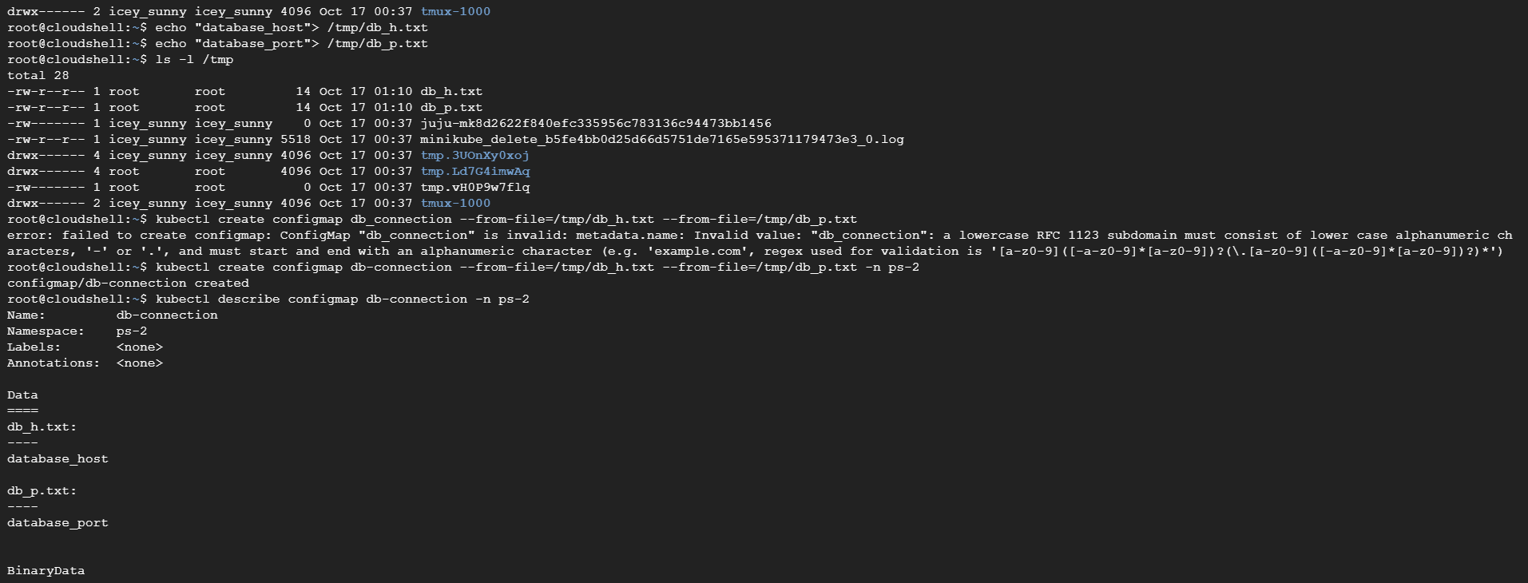

Lab 7:

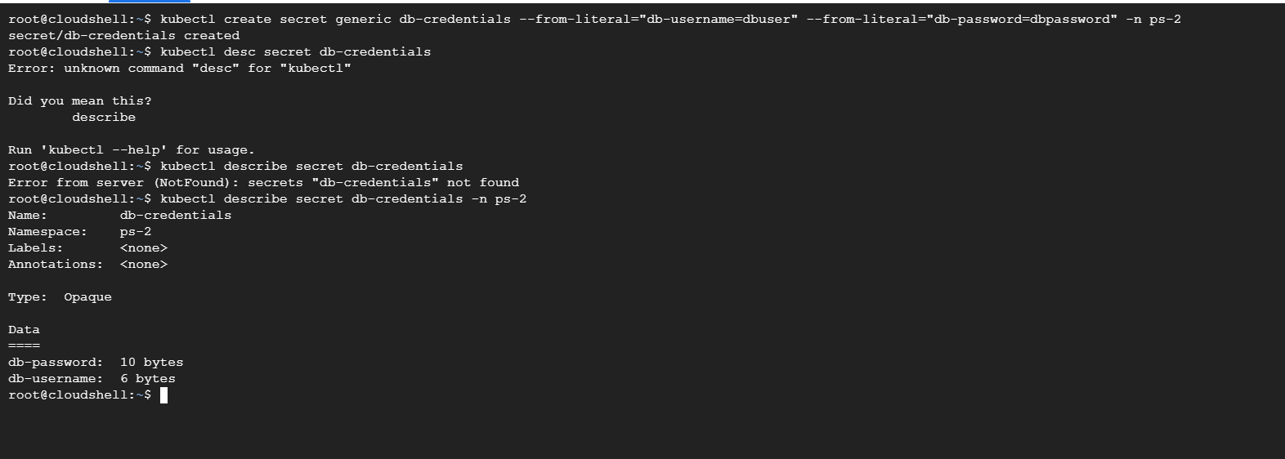

Lab 8:

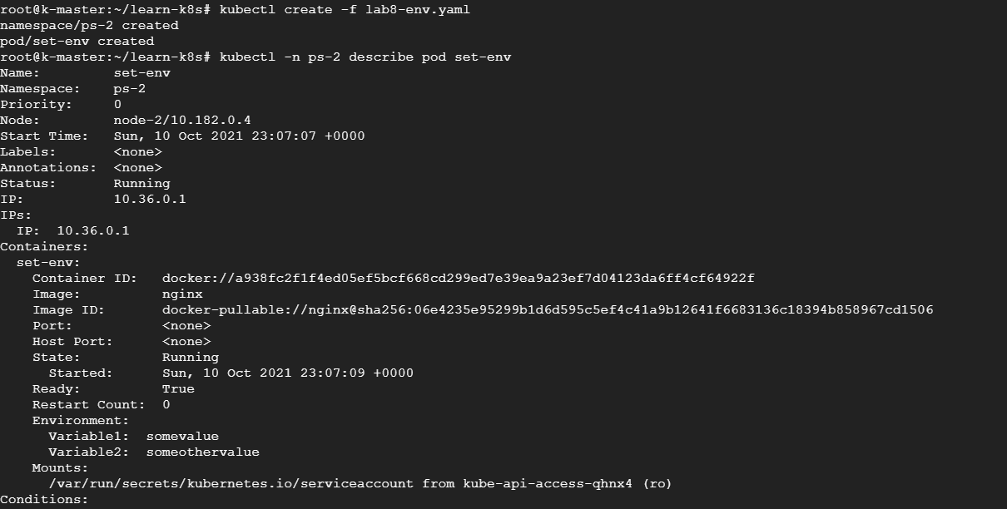

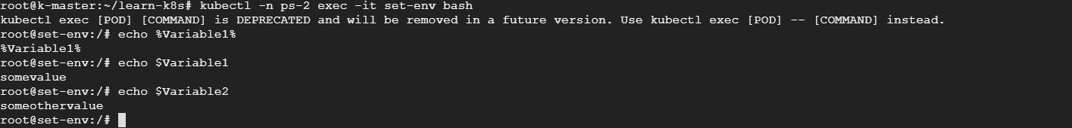

apiVersion: v1

kind: Namespace

metadata:

  name: ps-2

---

apiVersion: v1

kind: Pod

metadata:

  name: set-env

  namespace: ps-2

spec:

  containers:

    - name: set-env

      image: nginx

      env:

        - name: Variable1

          value: somevalue

        - name: Variable2

          value: someothervalue